Tips to Make Accessible Documents

Federal agencies, including USDA, are responsible for ensuring their information and services are accessible to persons with disabilities. By ensuring your final report is 508 compliant, you are helping the CIG program ensure that all individuals have equal access to the information you have provided.

Making a document accessible is easiest to do when you first create it. An accessible document is created so accessibility technology can be used, for example so the document can be as easily read by a low vision or non-sighted reader as a sighted reader. Many of the most common accessibility issues making documents difficult or impossible to use in a non-traditional way can be easily fixed. Below are ways to address the most common barriers to creating accessible documents.

Check accessibility while you work
In most Microsoft Office products, the accessibility checker can be found under the Review tab. To be notified of accessibility issues in your Office document or spreadsheet as you work, check the Keep accessibility checker running while I work check box. This is a basic accessibility checker and more in-depth testing should be completed to guarantee total accessibility.

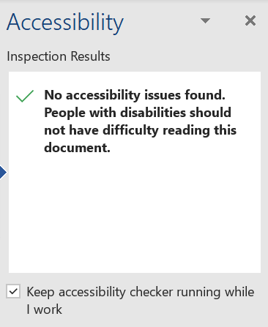

Add Alt Text
If a document is made available electronically, you must add ‘alternative text’ to your images using the 'Edit Alt Text' function which can be accessed by right-clicking on any image or can be added through the accessibility tracker. Screen readers will subsequently convey descriptions that have been added as an alternative to the user being able to view it. When writing ‘alt text’, you should consider what you are trying to convey by using the image. This will help you decide how to describe it so that your document makes sense to everyone. If the image is purely decorative you should mark it as such in the 'Alt Text' options so that screen readers are informed to ignore it.

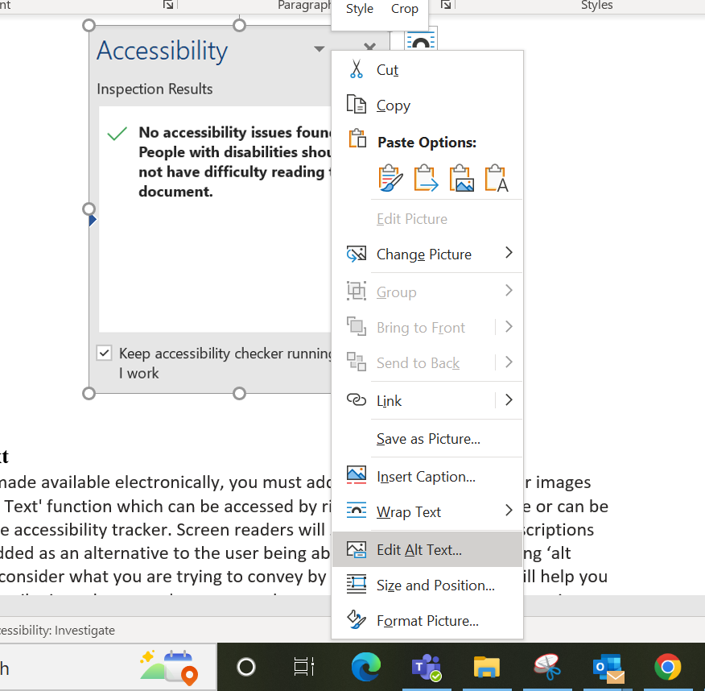

Use Correct Heading Structure

Headings in a document aid in providing logic and structure to a text. Headings allow the assistive technology to recognize the structure of the text and present the information in a logical fashion. Without headings, the assistive technology would have to guess at the structure (typically inaccurately) or would deem the document as simply not accessible. This means using a hierarchy of headings – such as Title, Heading 1, Heading 2, Heading 3, etc. which allows navigation of documents by their headings. In Word documents, headings are set using ‘Styles’ on the navigation bar. After highlighting the text you want to use as a heading, select your desired style from the formatting toolbar or the Styles Pane.

Pages should be structured in a hierarchical manner:
- A Heading 1 is the main page title. It is the most important heading, and there should be just one. Heading 1 is normally in the largest font in the document. Every document should have a title.
- A Heading 2 is a major section heading, smaller than Heading 1
- A Heading 3 is a sub-section of Heading 2 content, smaller than Heading 2, and so on (Think of headings in terms of an outline).

Structure Tables Correctly

Tables in Word need to have a simple structure and give column header information. To work with a screen reader, Word tables must not contain split or merged cells, completely blank rows or columns, or nested tables. The correct reading order for a table is to move through a table from top to bottom and left to right.

Complex Tables should be avoided. Data tables can be described as either simple or complex. A simple data table is one in which each cell corresponds with only one column header and/or one row header. In contrast, a complex data table is one in which there are nested columns or nested rows.

Layout tables should also be avoided. They do not have logical headers that can be mapped to information within the table cells.

Use Lists to Organize Information
Using numbered or bulleted lists in documents can be a very useful way of breaking up complex, content-heavy information, making it easier to read and follow. For the listing feature to work with screen-reading software, the author must create the list using the built-in list formatting within Word.

For people using a screen reader, the list itself can convey some valuable information including:
- where the list starts and finishes
- how many items are in the list
- what list item the user is on

Tag PDF files

PDFs need to be tagged for them to be accessible. Tags on a document take the place of visual cues that would regularly designate the logic and structure of text. For example, a reader without visual impairment could tell two paragraphs apart from each other by a space in between the two distinct texts. However, a blank space means nothing to someone who is visually impaired. For accessibility purposes, each paragraph would be distinctly tagged as a paragraph, tables would be tagged as tables, etc. Tags allow the assistive technology to recognize the structure of the text and present the information in a logical fashion. Without tags, the assistive technology would have to guess at the structure (typically inaccurately) or would deem the document as simply not accessible. Preparing a document through the accessibility Checker in Word helps make sure the PDF will be accessible.

Once you've addressed the accessibility issues in Word, you will want to save your word document as a Tagged PDF. Select File > Save As or File > Save a Copy. Expand the file type dropdown and select PDF (*.pdf), then select Options in the save dialog box. The Save As dialog box should open, select “Document structure tags for accessibility” and press OK.

