How to Use the Data Integrity Report Parameters
The design of the parameters for data integrity reports allows users to assess the quality of any and all data that are to be posted to Soil Data Warehouse for publication through Web Soil Survey. This includes both current official data and unofficial data being prepared for publication. Users can run the reports against the local or national database. Users can select which map units and components they want included in the analysis by selecting one or more of the parameters, including mapunit ownership, soil survey area symbol, taxon kind, major component flag, geographic applicability, and map unit status. Users can select one or more of the parameters to filter which data they need to review. Official data for the entire nation are included if none of the parameters are populated when a report is run against the national database.
The examples below demonstrate the flexibility and versatility of the report parameters for different datasets. The percent wildcard (%) can be used in the first two parameters. All parameters allow for blank entries.
Figure 1 demonstrates how few parameters are needed to run a report on official data for a whole region and for major components only. In fact, just the first parameter is required. “Official data” refers to correlated mapunits for a non-mlra soil survey area with a geographic applicability of “current wherever mapped”. Notice a hyphen (-) is used with the percent wildcard (%) in the first parameter to control which map units are included in the report. In the example, 1-% limits the reports to run on map units owned by Region 1 (e.g., map units owned by 1-IDF Idaho Falls, Idaho; 1-MTV Mount Vernon, Washington; etc.). Note also that the hyphen that follows the region number is part of the national naming convention.

Figure 1.
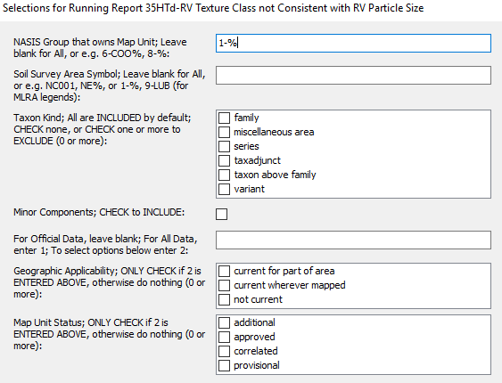
Figure 2 shows how to use the data integrity reports to check project work prior to the data becoming correlated into an official legend (i.e., a new map unit or DMU being developed within the confines of a project with the map unit linked to a MLRA legend). However, new map units must be linked to a legend, such as a MLRA or MSSO Legend, before the reports can work. Notice a hyphen (-) is used with the percent wildcard (%) in the second parameter to help control which data are assessed. In the example, 1-% limits the report to run on unofficial MLRA soil survey area legends owned by MLRA soil survey offices (MSSOs) in Region 1 (i.e. 1-IDF, 1-MTV, etc.).

Figure 2.
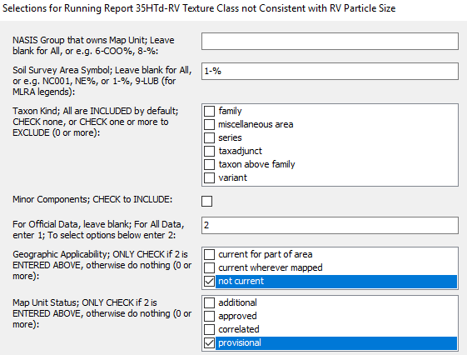
Figure 3 shows an example of using the parameters to select map units for an initial soil survey that is being progressively correlated.

Figure 3.
