Introduction to Using Peninized 232 Forms

By George Teachman

A peninized form is an Excel-based form that can be used with or without a digital pen to record data which can then be imported into a corporate database.

There are four methods of getting soils information into NASIS. Only three are currently being used. Deciding which method to use is somewhat dependent on the amount of detailed data you need to access in NASIS.

To input the least amount of data, you can use the peninized 232 form. Peninized 232 forms record the most commonly collected morphological, physical, and chemical data. The forms are set up to mimic the very familiar paper 232 forms. The data from these Excel workbooks can be imported into NASIS by clicking on the spreadsheet icon in NASIS.

For a moderate level of detail, you can use the Pedon PC program. The data from these Microsoft Access databases can be imported into NASIS by clicking on the appropriate icon in NASIS.

To record the highest level of detail requires entering data directly into the NASIS database using NASIS as the data entry tool.

The difficulty of entering data into NASIS is directly proportional to the level of detail required.

Anecdotal evidence indicates that using the Excel-based 232 forms to import pedon data into NASIS is faster than using either Pedon PC or NASIS itself.

The first thing to understand is that while the forms are described as peninized and were originally designed to be used with the digital pen in the field they can be used to record data collected either with the digital pen or as a regular Excel file by entering data via the keyboard.

There are four variants of the peninized 232 form to choose from. There is one for Histosols, one for subaqueous soils (SAS), and two for mineral soils.

With the exception of the 232 SAS form, each variant can be used to record and import into NASIS either historical or new descriptions. Historical descriptions can be taken from old paper 232 forms, field notes, or even taxonomic unit descriptions (TUDS) from published soil survey reports.

When entering historical It is NRCS Soil Science Division policy to enter historical profile descriptions into NASIS, the user enter the codes exactly as described in the historical record, except for the pedon's taxonomic classification. The pedon is to be classified using the latest keys to taxonomy based on the data in the description. This means that it is necessary to record obsolete terms and codes.

Since describing SAS soils is a very new practice, there are no historical descriptions for these soils, and thus the SAS 232 form does not allow obsolete terms and codes.

# How to Use a Peninized 232 Excel Form

The following section of this document describes how to use a peninized 232 form. A set of Excel-based peninized 232 forms has been developed and posted to the USDA Connect Digital Pen and Forms community. The forms are listed below. Note that all the file names include the date of the last update. In the file names below, the dates have been left out to reduce confusion regarding which date to use. The most current versions can be found in the USDA Connect Digital Pen and Forms community. To make communication easier the version number and date and extension have been left off of the file names listed below.

232 Histosol

232 JC232

Minl Mxd DE

232 SAS and VibraCore Log

**Note**: Each of these files can print either in ledger size (11 inches by 17 inches) or legal size (8.5 inches by 14 inches). The default is to print in ledger size. There are instructions displayed in each file when opened to print in the legal size.

Figure 1 is a generalized screenshot of the top of the forms.



Figure

# First Things First

Before entering data into a blank form it needs to know if the digital pen (along with the Capturx software) going to be used with this form at this time. To setup for using the digital pen, first click on the red button labeled DP as seen in Figure 1.

Clicking the red button will begin a series of dialog boxes with some questions that need to be answered. The questions will vary based on the previous question’s answer. The first dialog box to be displayed is shown in Figure 2.

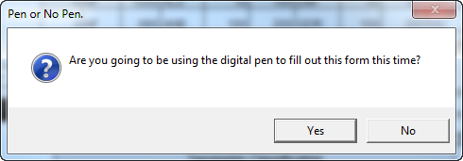

Figure

If you are not going to be using the digital pen this time click the ‘No’ button. The question and answer period is done and you can start adding data to the form.

If you are going to be using the digital pen then click the ‘Yes’ button. Another question will be posed, as shown in Figure 3.

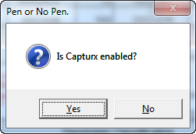

Figure

If Capturx is enabled, click the ‘Yes’ button. The Q&A session is now complete and you can start adding data to the form. NOTE: If you don’t have Capturx for Excel installed on your machine, click ‘Yes’ to end the Q&A session and start adding data to the form.

If you haven’t already enabled Capturx, click the ‘No’ button and the next question is asked, as shown in Figure 4.

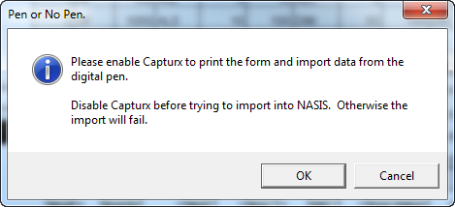

Figure

To enable Capturx and be able to print forms for use with the digital pen, click the ‘OK’ button or the ‘Cancel’ button and the Q&A session is done. Now, enable Capturx.

# Controlling Cursor Movement

Earlier versions of these forms required the user to move the mouse cursor to a data entry field and do a left click to put the cursor in that field. Or, the user could use the Tab key, the Enter key and/or the Arrow keys to move the cursor to the data entry field of interest. These actions are very repetitive and lengthen the amount of time it takes to enter all the profile data. They also have the potential to create errors or even inadvertently modify the form to the point that the import into NASIS could fail or that the data was imported into the wrong columns in the database. One of the most often seen errors is using the Tab key to move the cursor out of the data entry field after the user completed entering the data. If the user fails to press the Tab key enough times to move the cursor past labels and starts typing the data entry for the field the user thinks they are in the label field can be overwritten and the data wouldn’t be imported into NASIS.

In this version there are two ways to control the cursor movement, i.e. Predefined Cursor Path or PCP. First way is to click on the button labeled PCP at the top of the form. This method is used only in the site section of the form. When the PCP is enabled, the user can enter data into the first field, the Sample Date, and then hit the Tab (or Enter) key to move to the next non-label (data entry) field. At the end of a row the Tab (or Enter) key will go to the first field on the PCP in the next row. When the form is first opened the PCP will be enabled and the form looks like Figure 5. The Right Arrow key does not act like the Tab key in this situation. Using the Right Arrow key will disable the PCP.

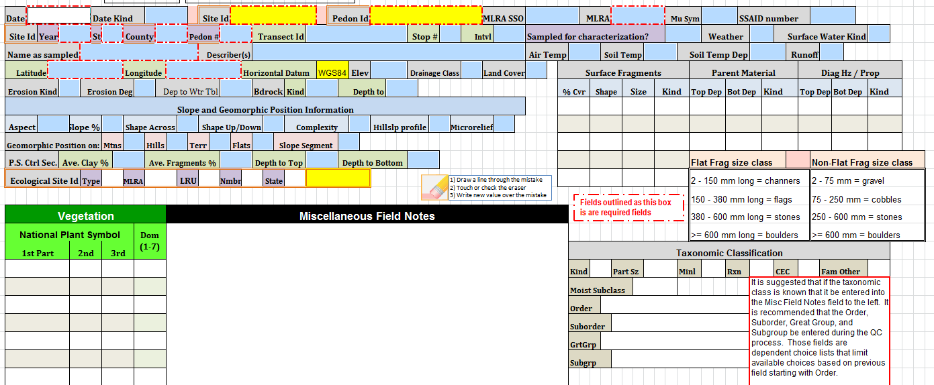

Figure

If the user uses any of the arrow movement keys or the use the mouse to click on any cell not included in the PCP, the PCP is disabled and returns the Tab (or Enter) key to its normal behavior. To reset the PCP click on the pink button with the label ‘PCP’ at the top left of the form, as shown in Figure 1. This will re-enable the PCP and puts the cursor in the Sample Date field. The user will need to Tab (or Enter key), or Shift Tab to go in reverse, through the fields to get to the field they left off at. Once the cursor is in the last field of the PCP hitting the Tab (or Enter) key again will wrap the cursor around to the first field, the Sample Date field.

A drawback to this method is that only a limited number of data entry fields can be included in the PCP definition. But, this method is safe and has only a limited potential for introducing errors to the data or the form.

The second method of defining the PCP has the potential for losing data. This method relies on the non-data entry fields being protected from change. If this method is enabled (by protecting the worksheet), the cursor will only stop in data entry fields. There is no limit to the number of fields that can be tagged to be skipped in contrast the very limited number of fields in the first PCP method. In this method, using the Tab key will move the cursor horizontally across the form and wrap around to the next available data entry field after the last data entry field on the row.

The Arrow keys retain their normal behavior, for the most part. Depending on the design of the form the Arrow keys may exhibit a little different behavior than normal. The user will quickly come to know how the Arrow keys behave after using a particular form a few times.

The main drawback to this method is when the form is used in conjunction with the digital pen. The digital pen software does not work correctly when a worksheet is protected and data may be lost during the import process.

So, it is up to the user to determine if the form will be used with the digital pen or not. At this time, it seems that most users of the forms do not use them in conjunction with the digital pen. Therefore, the default state for the form will be to have the worksheet protected.

If the user wants to use the form with the digital pen, then the user will need to unprotect the worksheet.

To determine the protection status of the worksheet the user needs to click on the Files tab with the worksheet open and active. Clicking on the File tab at the upper left corner of the ribbon area of the workbook will display some basic information about the workbook. See Figure 6 below:

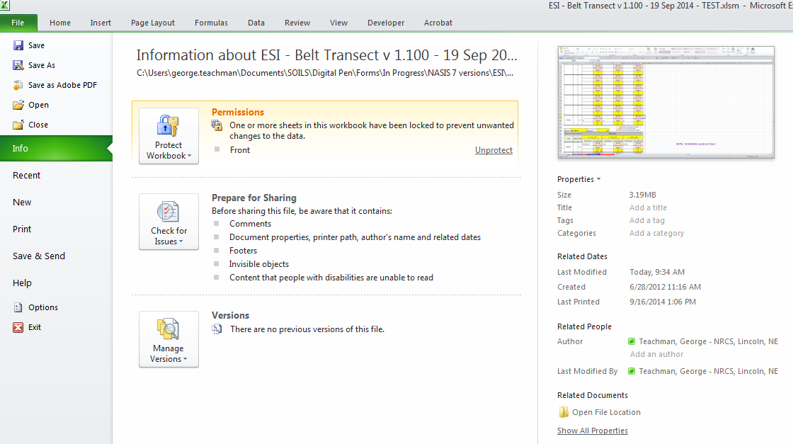

Figure

If the form is protected, the highlighted section on the File tab, the Permissions section, as seen in Figure 6 will show ‘Front’ and at the right side of that section will be an underlined word, ‘Unprotect’ as depicted in Figure 7.

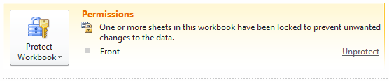

Figure

If the user is going to use the form with the digital pen they will need to click on ‘Unprotect’ before printing the form from the Capturx ribbon. The Capturx ribbon will need to be enabled BEFORE unprotecting the form. After unprotecting the form the user will need to save the file with an appropriate name and in an appropriate location, before printing from the Capturx ribbon. The original file that was downloaded from one of the storage sites is in a read only mode. It is best if you keep this file as is and save it after opening it prior to printing from the Capturx ribbon.

If the form is not going to be used with the digital pen you should still open it and save it with an appropriate name and in an appropriate location.

If you were to change the status of the original file to be not read only then this file could be saved with the same name and if used with the digital pen you would lose the blank file because Capturx imports data from the digital pen into the exact file the paper forms were printed from. You would have to go back to the were the files are posted and download the file again.

When the cursor is in a choice list field the user can use the mouse to click on the downward pointing triangle to access the choice list and select the appropriate choice.

**TIP:** This action is also available via the keyboard. Simultaneously click and hold the Alt and Down Arrow keys to open the choice list. Then, using the Up/Down Arrow keys to move to the wanted choice and hitting the Enter key will put the choice in the data entry field. This action will not disable the PCP.

**Managing Choice Lists**

One of the major benefits of the forms is the ability for the user to record obsolete codes often found in older (historic) descriptions. Obsolete codes can be used in any field that may have obsolete codes, with the exception of the taxonomic classification fields. As previously noted the taxonomic classification fields do not allow the use of obsolete codes. This allows for the entry of historic pedon data which may contain codes that are now obsolete. Since there are no historic subaqueous soil descriptions, the SAS 232 forms do not have the option of entering historic codes.

The forms also use the concept of dependent choice lists where the choices available for a field are dependent upon the choice in a previous field. Dependent choice lists are used in limiting the choices for County FIPS code; based on the value entered in the State field. Dependent choice lists are also used in the Taxonomic Order, Suborder, Great Group, and Subgroup fields on the.

One of the major drawbacks to using NASIS, Pedon PC, or the Excel 232 forms is that some of the fields have a large number of allowable choices. This forces the user to waste time scrolling through a large number of choices to find the one needed. These forms include the capability for the user to limit the number of choices displayed. This capability allows users to limit the number of choices by removing those that do not apply to the area and/or soils that do not exist in their area of concern. The user is given the option of removing unwanted/unneeded choices from the following fields with a large number of allowable choices:

|  |  |
| --- | --- |
| Parent Material | Bedrock Kind |
| Fragment Kind | Surface Fragment Kind |
| Diagnostic Feature Kind | Concentration Kind |
| Landscape | Landform |

Table

The user can edit (remove choices only) these choice lists in three of the four versions of the 232 forms. The SAS form only allows the user to modify the choice lists for the Parent Material, Fragment Kind, Landscape, and Landform.

The following section contains instructions on how to edit the long choice lists.

# Method to Remove Choices From Long Choice Lists

There are several choice lists that are quite long and can be irritating to use. Two methods have been incorporated into the 232 workbooks to limit the choices displayed, thus decreasing the amount of time needed to complete the form.

The first method, using Dependent Choice Lists, has already been addressed. It should be noted that this method is automatically used. This means the user does not need to do anything to invoke this method.

The second method is to allow the user to interactively select which choices will be displayed. Unlike the first method, the user must invoke this capability. The user can utilize this method on one or more of the eight long choice lists.

With the second method, the user selects which choices they want to remove from the original choice list. This method is very useful when done prior to any data entry. It creates a default set of choice lists. In this way, the office or individual user can create a default workbook.

# Using the Dependent Choice List Capability

Figure 8 screenshot shows the Taxonomic Classification section on the first page of the Front form/worksheet. The cursor is in the Order field, which shows the choices available, and “inceptisols” is selected.

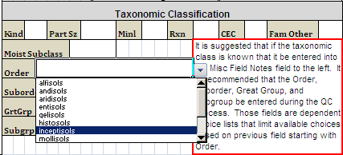

Figure

After selecting an order, the following fields will have choices limited to just the selected order, in this case Inceptisols. After moving to the Suborder field and clicking on the downward-pointed triangle, it can be seen that only a few choices are allowable. Figure 9 shows that Inceptisols has been selected as the order and that the user has highlighted “udepts” as the suborder.

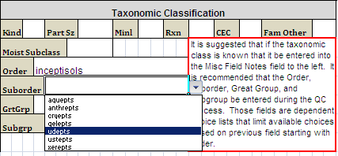

Figure

The same process is repeated in the Great Group and Subgroup fields until the user has selected “dystric fluventic eutrudepts” as the choice for Subgroup (shown further down). Notice that in the case of Subgroup, because there are more choices than can fit in the choice list box, a vertical scroll bar has been added to allow the user to scroll through the list.

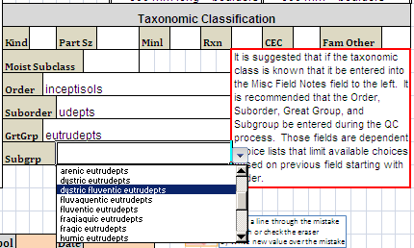

Figure

# Editing Long Choice Lists

To edit the choice list for one of the fields mentioned above, the user must click on the yellow tab at the bottom of the Excel window. The user will see eight choice lists, namely:

|  |  |
| --- | --- |
| Parent Material | Bedrock Kind |
| Fragment Kind | Surface Fragment Kind |
| Diagnostic Feature Kind | Concentration Kind |
| Landscape | Landform |

Table

The eight choice lists shown in the table above are available in all 232 workbooks. The four names highlighted in yellow in the above list only ones available in the 232 SAS workbooks.

To edit one or more of these lists, follow the steps below.

After clicking on the yellow tab labeled ‘Advanced’, scroll horizontally until you see the name of the list from which you want to remove choices. For this example, the Parent Material list is used.

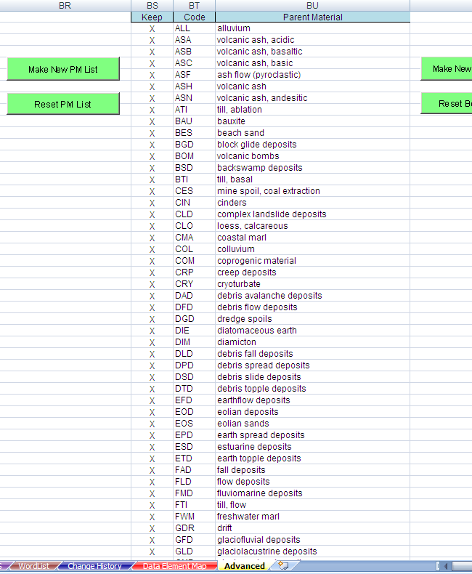

Figure

Put the cursor in the second row of the column named Keep. Then moving down the column one row at a time, delete the “X” out of the cell of the row with the choice you do not want displayed in the choice list for that field. Figure 11 shows that several rows (both contiguous and noncontiguous) have had the “X” deleted.

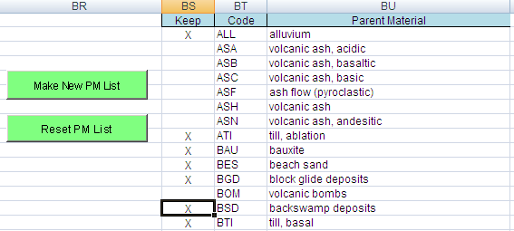

Figure

If you inadvertently delete the “X” from a row you want to keep or simply decide after deleting the “X” that you do want to display that choice, simply type upper case “X” in the appropriate cell.

After indicating the choice(s) you do not want displayed in the choice list, click on the Make New PM List button. The screen will flash and may show processing. At the end of the processing, the cursor will be located in the second row of the column named Code, as shown in Figure 13.

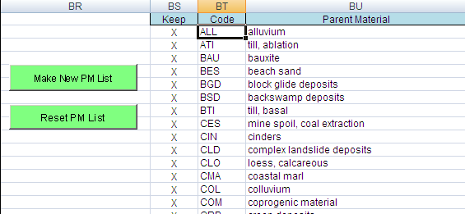

Figure

Once you have edited one or more of the available choice lists, you should click on the green tab with the name Front and save the workbook with an appropriate name, for example, SSO 12-GRR - 232 JC – default – 3 Mar 2014.

When you put the cursor on the field whose choices you have limited, you will notice that the choice list displays the last eight choices instead of the first eight and that there will be a blank space where a choice has been removed. You will need to scroll up to find the choice you want.

This issue is irritating but not a bug. It is being investigated so that it will not occur in a later version of the forms.

If a choice or choices were removed but should be included and the error was not noticed until after clicking on the Make New PM List button, you will need to click on the Reset PM List button to display the original choice list and then redo the selection process.

# Adding Data from Historic Pedon Descriptions

Another major capability of the Excel 232 forms is the ability to record data as it was originally recorded. With the exception of the Taxonomic Classification fields the user has the ability to add previously used, but currently obsolete, codes and terms to the list of allowable entries for a large number of fields. To do this, follow the instructions found in the next section.

Figure 14 shows a section of the top of the form that addresses historic pedon data entry.

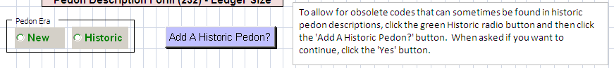

Figure

The text box provides a short description of how to prepare a 232 form to allow the entry of obsolete codes. Below is a more detailed description with screen shots of what you can expect to see.

NOTE: The option of entering historic data only applies to pedon data you are entering via the

keyboard. It is not an option if the digital pen is used to fill out the form.

When a 232 form is first opened obsolete codes cannot be entered. They are not available in the drop down choice lists.

When entering a historic pedon, you will not know if the describer actually used any of the now obsolete codes but it should probably be assumed that such codes were used. Thus, the choice lists must be modified to include obsolete codes. Follow the steps below.

Left click on the word “Historic” (in green) in the radio button group entitled “Pedon Era.” A black dot will appear in the circle to the left of “Historic,” as seen Figure 15.

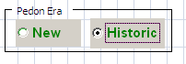

Figure

Next, click on the button labeled “Add A Historic Pedon?” The following dialog box will appear.

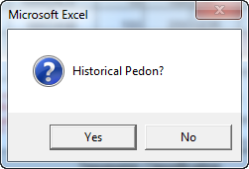

Figure

If you are entering data from a historic pedon, click on the ‘Yes’ button. If not, click on the ‘No’ button. When the ‘Yes’ button is selected, the following dialog box will be displayed.

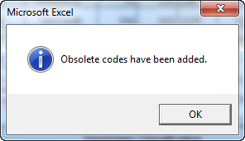

Figure

Codes that have been identified as obsolete have been added to the appropriate choice lists, and you will be able to select them like any other code. Click on the ‘OK’ button and start entering data.

If you click on “No” in the 'Historical Pedon?' dialog box, the following will appear.

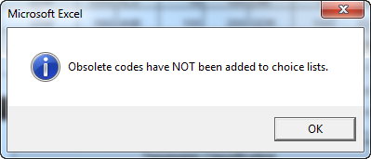

Figure

Click on ‘OK” and enter pedon data. You will not be able to select obsolete codes.’

The set of Choice Lists that are modified for use when entering Historic pedons is shown in Table 3.

|  |  |  |
| --- | --- | --- |
| Bedrock Kind | Landform | Redoximorphic Kind |
| Color Chroma | Landscape | Redoximorphic Location |
| Color Hue | Microrelief | Redoximorphic Size |
| Concentration Kind | Mottles Size | Root Size |
| Consistence Dry | Parent Material | Runoff |
| Consistence Moist | pH Method | Slope Position |
| Diagnostic Feature Kind | Pore Shape | Slope Shape Across |
| Effervescence Agent | Pore Size | Slope Shape Up/Down |
| Erosion Kind | PVSF Distinctness | Structure Grade |
| Fragment Kind | PVSF Kind | Structure Size |
| Geomorphic Component Flats | PVSF Location | Structure Type |
| Geomorphic Component Hills | Redoximorphic Hardness | Surface Fragment Kind |
| Land Cover |  |  |

Table 3: Choice Lists Modified

An additional macro has been added that can be used to reset choice lists that have been expanded for use with historic pedon descriptions back to the current allowable choices. There is no button for this macro. The user will need to click on the Developer tab to display the Macros icon, as shown in Figure 19.

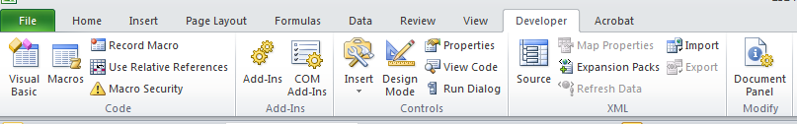

Figure

Clicking on the Macros icon will display, as shown in Figure 18, a list of available macros which change depending on what the user selects in the ‘Macros in: ’ field. The user should select the ‘This Workbook’ in this field. Then in the list of macros scroll down to the macro named ‘Sheet3.ResetChoiceLists’ and double click on it or click one-time and then click on the Run button.

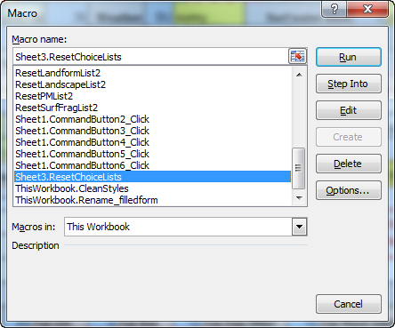

Figure

# Quality Control of Data Imported from a Digital Pen

This section discusses forms that have been completed using the digital pen and quality control (QC) after the data has been downloaded from the digital pen into the Excel workbook. You will interact with the two groups of buttons Figure 21.

If you entered data directly via the keyboard, you will have limited interaction with these buttons. You will only need to use the ‘Error Check’ button.

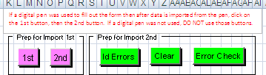

Figure

The information in red is a brief instruction on using these buttons. Below is the instruction in a more readable form.

If a digital pen was used to fill out the form then after data is imported from the pen, click on the 1st button, then the 2nd button. If a digital pen was not used, DO NOT use those buttons.

Users must click on the pink button with the label “1st” to run the CleanStyle macro and then to click on the pink button with the label “2nd” to run the Rename_filledform macro.

After these two macros have been run, the user can start performing the QC of each of the imported worksheets. With the Capturx Review Pane open, the user visually checks for errors. The three green buttons will make the QC process easier. The green buttons labeled “Id Errors” and “Clear” will only be used if a digital pen was used to fill out the forms.

The Error Check button can be used whether or not the digital pen was used.

After clicking on the two pink buttons, click on the first green button labeled “Id Errors.” This will run an Excel process that puts red circles around those fields that have failed the field level validation.

There are other potential errors that will not be identified using the Id Errors button. The Id Errors process will not identify errors in text or alphanumeric fields. The optical character recognition processor in Capturx for Excel has problems with these types of fields. You will have to visually determine whether or not those fields are correct. Examples of those fields are User Site Id, User Pedon Id, Transect Id, Horizon Designation, and text notes. Note that not all fields circled by red circles are in error, specifically color value and chroma. This issue is yet to be addressed. If the user has not entered data directly into the User Site Id and User Pedon Id fields then these fields will not have problems with the optical character recognition software.

After verifying and fixing errors with the red circles, you should click on the second green button labeled “Clear.” Clicking on this button will remove all the red circles drawn by the Id Error button.

After fixing all the errors that you can find either through visual inspection and/or by utilizing the Id Error process, you should run the Error Check macro, by clicking on the last green button labeled “Error Check.” This button can be used if the data was entered directly via the keyboard or if the digital pen was used and worksheets were imported into the workbook.

The 1st, 2nd, Id Errors, and Clear buttons run their respective macros without any notifications to the user. The Error Check button/macro may interact with the user prior to completing if the user indicated that this form was a continuation form. Other than this potential interaction the error checking process will display a popup message box when it completes the error check.

The Error Check macro checks for a multitude of potential errors and potential inconsistencies. When it identifies an error or inconsistency it writes a message to the error log file that is displayed after the macro is completed. Figure 22 is an example of the message displayed when the error checking is completed.

A Fatal error is one that will cause the import into NASIS to fail. Clicking on the OK button will display the error log file containing information about the error and where it was found. The error report below is not the one linked to Figure 23.

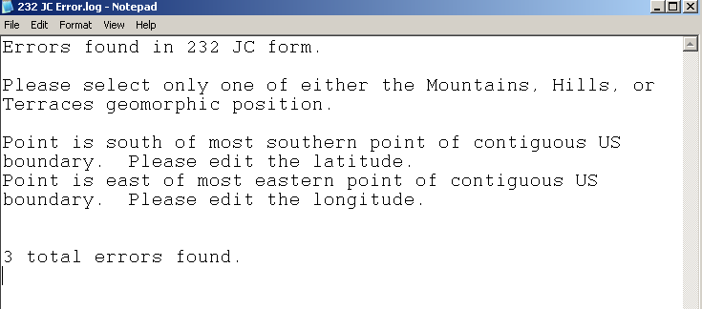

Figure

This file can be found in the C:\temp directory on your computer. It can also be printed to help you fix the errors that were found.

Once you have fixed the errors, you should run the Error Check macro again. At some point during the error fixing iterations, you will have fixed all the errors that have been found and you will get a message dialog box like the one below.

The final error check is made when you import the spreadsheet into NASIS. NASIS is able to identify errors that the data validation methods cannot. Some validations, however, can catch some potential errors that NASIS does not check upon import (such as checking if the horizon lower depth is less than the horizon upper depth).

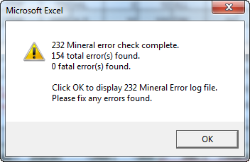

Figure

Each of the peninized 232 form variants operates in much the same manner as described above.

# Adding Plants

Please refer to Figure 24 for the following discussion on how to add plants found to the forms.

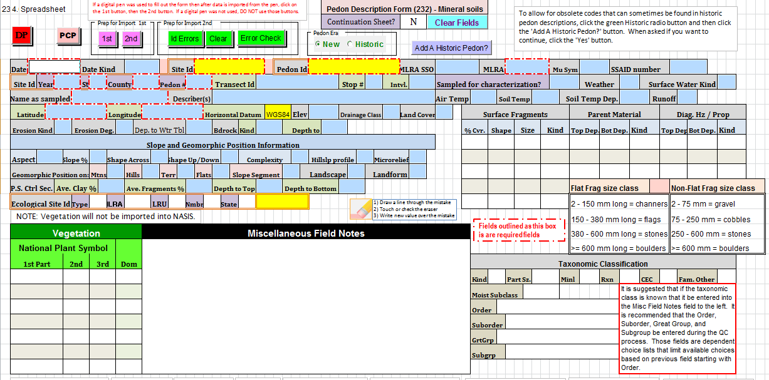

Figure

To enter plants found you will need to know the National Plant Symbol (NPS) as listed in the USDA PLANTS database. You do not need a common name. The NPS field has been separated into the three distinct pieces that make up the National Plant Symbol. The reason for splitting the NPS into its constituent pieces is that the Capturx for Excel optical character recognition software has problems with a field that mixes both alphabetic and numeric characters.

1. First part is a four alpha character field. This is the only required field of the three that make up the NPS. It must be four characters and each must be a letter.
2. Second part is a one alpha character field. This is an optional field and if used must be one letter.
3. Third part is a one or two digit numeric field. This is an optional field and if used must be greater than or equal to 2 and less than or equal to 99.

The Error Check macro checks the concatenated value against the most recent list of National Plant Symbols in the NASIS Plant table.

NOTE: The plants data is not imported into NASIS because if ESI data associated with the User_Site_Id already in NASIS is imported a second Vegetation Plot record is created and this will cause problems when analyzing and reporting vegetation data. The only way we could ensure that this didn’t happen is by not importing the vegetation data from the 232 forms. If the user knows that this site will never have any other vegetation data associated with then the user will need to go into NASIS and create the necessary link to the Site Observation record to the Vegetation Plot table and enter the data into the Plot Plant Inventory table by hand.

# Adding Some of the Super 7 Data Elements

A recent major change to the two mineral 232 forms is an additional page containing fields for values for what have been called the ‘Super 7’ data elements. Some of the Super 7 data elements have fields for their values in other areas of the form. The remaining fields are located in the new Field Estimate of specific data elements page as shown in Figure 25.

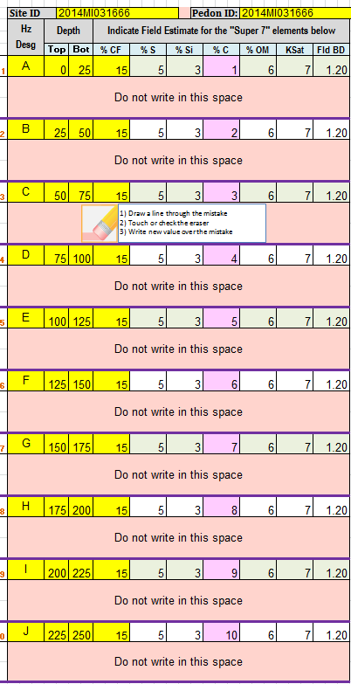

Figure

* %CF. This is an auto-populated field (thus the yellow color of the field) that is derived from the sum of the estimated % Fragments fields in the Horizon section of the form. The Pedon_Horizon_Fragment table is a child table of the Pedon_Horizon table. Since, there can only be up to three records in any of the Pedon_Horizon child tables, the %CF is the sum of the three Fragments Pct. fields in each horizon
  + This value is stored in the Fragment_Volume_Total field in Pedon_Horizon table.
* % Sand. The value is the field estimate of total sand. This is not a measured value. If you have a measured value it should be entered into the Pedon Horizon Lab Results table using NASIS.
  + This value is stored in the Sand_Total_Estimated field in the Pedon_Horizon table.
* % Silt. The value is the field estimate of total silt. This is not a measured value. If you have a measured value it should be entered into the Pedon Horizon Lab Results table using NASIS.
  + This value is stored in the Silt_Total_Estimated field in the Pedon_Horizon table.
* % Clay. The value is the field estimate of total clay. This is not a measured value. If you have a measured value it should be entered into the Pedon Horizon Lab Results table using NASIS.
  + This field is auto-populated from the % Clay field in the Horizon section of the form. However, the user can overwrite this field if they wish. This is why the field is pink and not yellow, like the other auto-populated fields.
  + This value is stored in the Clay_Total_Estimated field in the Pedon_Horizon table.
  + If for some reason the user doesn’t want to use the %Clay field in the first horizon section of the form they can enter the %Clay in this cell so as to keep most of the Super 7 values together in one section to aid in the use and analysis of this data.
  + The user needs to know that once the user enters data into this field it is no longer linked to its respective %Clay field further up on the form.
  + NOTE: The import process only looks at the value of this field when it imports percent clay. It does not import any data entered in the first %Clay field.
* % OM. The value is the field estimate of total organic matter present. This is not a measured value.
  + This value is stored in the Pedon_Horizon_Field_Measured_Properties as Estimated % OM with the unit of measure as ‘percent’.
* Ksat. The value is the field estimate for the horizon’s Ksat. This is not a measured field.
  + This value is stored in the Pedon_Horizon_Field_Measured_Properties as Estimated Ksat with the unit of measure as ‘um/s’.
* Field BD. The value is the field estimate for the bulk density of the soil at the time the soil was described. This is not a measured value.
  + This value is stored in the Pedon_Horizon_Field_Measured_Properties as Estimated Field Bulk Density with the unit of measure as ‘g/cc’.

# What does the choice list code mean?

An often heard comment/complaint about the Peninized 232 forms is that the user doesn’t always know what the codes in the choice lists relate to. When the user is filling out the form in the field they must often pull out the Field Book and find the section that corresponds to the section on the form to find a list of allowable codes and their meanings. This is time consuming and frustrating.

The forms now have most of the choice lists, with codes and their meanings, displayed on the form itself. In most cases the choice lists are printed on the page of the form they are used, but not always. Also, the choice lists with a large number of choices, those described in the section of this document on personalizing choice lists, are not displayed. An example is shown in Figure 26.

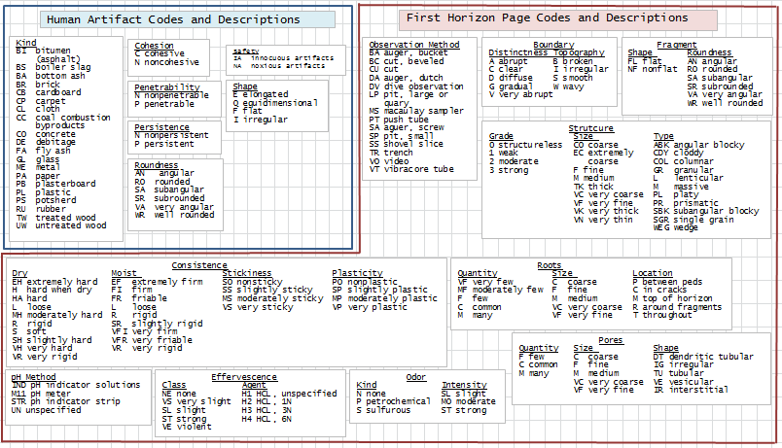

Figure

More Than Ten Horizons?

The 232 forms only have space for ten horizons. Note that this is only a limitation of the 232 Excel-based forms. Neither Pedon PC nor NASIS has a limit on the number of horizons that can be described for a single pedon. Ten horizons are usually more than enough to completely describe a pedon’s profile. However, there are times when ten horizons are not enough. What does the user do then?

In Figure 1 there is the ‘Continuation?’ label. The field associated with this label is a Y(es) or N(o) field. If the user needs to describe more horizons, then they should change this field from the default of ‘N’ to ‘Y’.

After entering a ‘Y’ into the ‘Continuation?’ field the data entered in the horizon section of the form will need to be erased. This can be a tedious and error prone process. To make this easier, a click on the ‘Clear Fields’ button will do the trick. This will clear all the fields the user entered data into in all the horizons. It will not clear the fields in the site portion of the form.

The user now just enters data for the extra horizons as normal.

Importing a continuation form into NASIS will fail if the data from the first ten horizons has not yet been entered. When the pedon data described on the two or more forms is imported into NASIS they must be entered in order. Meaning, the first form used to describe the first ten horizons must be imported prior to any additional continuation forms. If there are more than one continuation forms (I confess I cannot imagine a profile with more than 20 horizons) then the first continuation form must be imported first, and so on.

The most important thing to remember when using a continuation form is not to change any of fields in the Site section of the form. To help avoid this the data fields in the Site section of the continuation workbook will have their status changed from editable to protected once the user enters ‘Y’ in the Continuation field and clicks on the Clear Fields button.

Once the Clear Fields process is complete, and it may take a couple of seconds, the cursor will be placed in the first data field in the horizon section of the form. Just start entering data from there. Remember to save the continuation form file with a different name than the first form was called so you can tell which of the forms the continuation form is to be linked with.